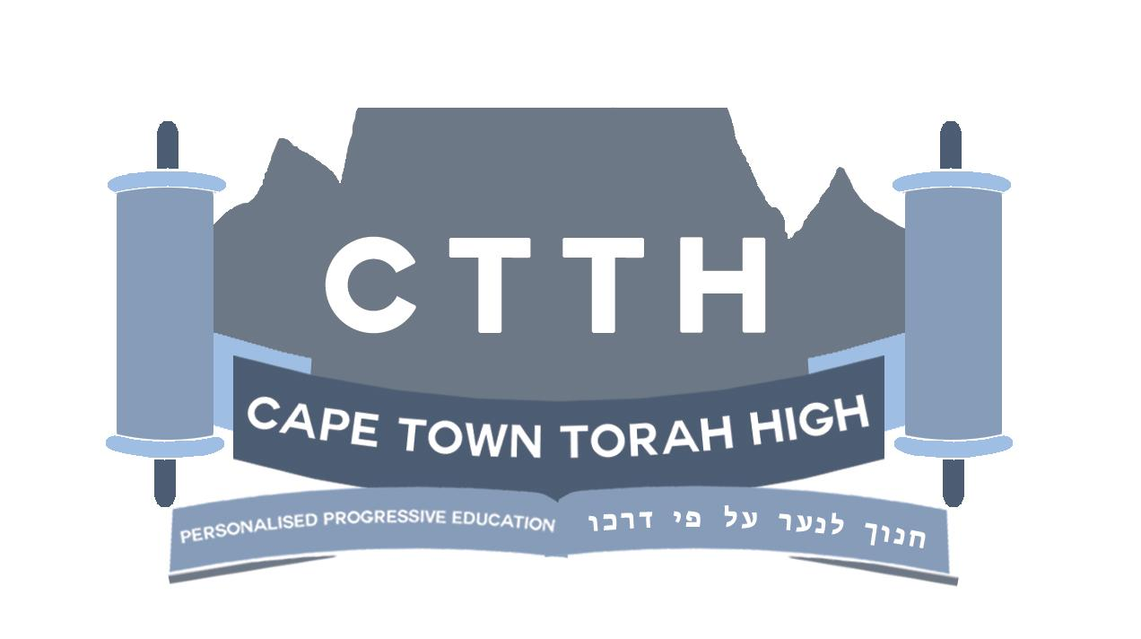

School Brochure

2016

Table of Contents

Mission Statement 3
About Us 3
Teaching Methods 4
Self Pacing vs. Group Learning 5
Tests and Exams 6
Time Management 7
Ergonomics 8
Kodesh Curriculum 9
General Studies Curriculum 10
Matric 11
Extra Curricular Activities 12
President’s Award 13

Mission Statement
Cape Town Torah High is a Torah-based Jewish High School in Cape Town driven by a community of families.

About Us
We are registered with the Western Cape Department of Education and we are a member of the Independent Schools Association of South Africa (ISASA).
We offer a well-balanced dual curriculum, covering all the normative Jewish Studies Kodesh subjects together with the full range of General Studies subjects as determined by the South African Caps Curriculum and by international standards (and a wealth of electives).
Our matriculants’ school-leaving certificate reflects an internationally-accredited curriculum which complies with, and is recognised by, AdvanceED (US Accreditation Board), WASC (Western American School Association) and The South African Matriculation Board.
This blend of Kodesh and a challenging secular studies program encourages our students to think critically, behave ethically, and embrace Torah learning and living.
Our passion is to inspire the next generation of Jewish young men and women in Cape Town to take their place in society as educated, proud Jews, who live with a love of Torah, a love for their fellow Jews, and a love for the land of Israel, together with an informed sense of responsibility to their broader community and the world.
While the teaching philosophy remains the same throughout the school, there are subtle differences between the Junior High and Senior High phases of the school. This is largely due to maturity of the student and the curriculum platform. However, we aim to weave the same ethos throughout the school, and you will thus read many similarities.

Teaching Methods
Junior High
- The instructional material is presented through verbal instruction and written text. Books written by accredited authors are used over textbooks as far as possible.
- Teachers prepare detailed rubrics which are designed to make the objective of the task clear and guide the student to success.
- Learning is enhanced with the use of video presentations and experiential learning in the form of educational outings, providing real time learning.
- Students who have passed a unit or have mastered a concept are encouraged to help students who are busy with that section. This reinforces the learning, builds the confidence of the leader, and creates a community of ‘givers’.
- We strongly encourage parents to be actively involved in the learning material. Parental involvement is directly related to achievement. A dinner conversation, a parent acting as a sounding board, a parent contributing what they know about a subject are all highly valued.
- Students work according to timetables.

Senior High
- Teachers are a ‘guide at the side’ as opposed to the mainstream model of ‘sage on the stage’ - teaching, facilitating, and mentoring students.
- Teach primarily through one-on-one interaction, specifically when ‘live’ support is required in the form of teaching, explaining, brainstorming, editing, reflecting, encouraging and believing.
- Internal proctors (buddies) can be students enrolled in the course, who have passed early units in the course, and are now assisting students with the units they have already mastered.
- Instructors prepare a written study guide that is designed to assist students with learning. Study guides contain study objectives and questions that focus students’ attention on important material to be learned, and provide a clear indication of what students are expected to do. It may also include instructor comments used to elucidate difficult points, exercises and practice problems to prepare students for the unit assessment, thought questions to stimulate students’ interest in the exploring the subject matter further, and a supplementary reading list.
- Teachers invigilate tests that are administered and marked by the UNHS, providing feedback regarding academic results and support for road mapping remediation or acceleration.
- Students create their own timetables, within consideration of teacher availability and tutorial/group lab requirements. They are also required to continue coursework at home due to the dual curriculum load.

Self Pacing vs. Group Learning

Junior High
Self Paced Learning
- Subjects, that are dependent on an individual’s ability and entry level skill, are self-paced.
- The learning style for these subjects is modular based and on demand. This means that students progress at their own pace and can write their exams at dates and times that suit them. The latter allows for a wide range of students’ abilities to be accommodated, from academically challenged to gifted, without feelings of discrimination.
- While students are encouraged to proceed at their own level and pace, there is minimal level. In other words, a student cannot go slower than an acceptable rate, thus we prevent individuals from falling behind.
- These subjects include, Maths, English Writing, Accountancy, and Science from Grade 8.
- Self paced learning allows for individual attention, decreasing the need for private tutoring.

Group Learning
- Subjects with socially conceptual content are taught as a group, encouraging discussion, group projects and collaboration. These subjects include: History, Geography, English Literature, Economics and Technology.

Senior High
Self Paced Learning
- A system of individualized student pacing following the use of unit mastery is used.
- Because some students take more time to master individual units, students will thus progress through a course at different rates. Some students finish a course relatively quickly, while others require longer to finish the course.
- As such, once a course has begun, students enrolled in the same course, will work on different units of the same course depending on their rate of progress.
- Course selection is discussed and facilitated on an ongoing basis, all the while keeping in mind the student’s future career goals.

Group Learning
- Students are brought together for tutorials on Literature, Maths, Social Sciences and Natural Sciences.

Tests and Exams
Junior High
- Content is separated into portions called units.
- To advance from one unit to the next, students must demonstrate that they have mastered the material. Students demonstrate mastery by taking an assessment that requires a minimum score of 70%.
- Students are encouraged to take a re-evaluation if needed, as we primarily promote knowledge, not marks.
- Mastery of a unit is assessed in multiple ways including essays, orals, traditional tests, multiple choice tests, technical or practical demonstrations.
- There is no “exam period” at CTTH, although we do have “crunch time” when projects and assignments are due at the end of the term. But with adequate management of time, by both the teachers and the students, this should be kept to a minimum.
- Grades are not used to rank students relative to each other, but are rather used as an incentive to further promote knowledge and achievement.
- Progress reports are recorded as results are reached. Parents have permanent access to these progress reports so that they can encourage and motivate their children at home.
- Once a year a Transcript is produced where each subject is given an average symbol.

Senior High
- Content is separated into portions called units, with approximately 6 units making up a half-year semester course.
- To advance from one unit to the next, students must demonstrate that they have learned the unit’s material. Students demonstrate mastery by taking an assessment that requires a minimum score of 70%.
- Mastery of a unit is assessed through tests set and marked by the UNHS. These primarily take the form of unit evaluations, projects, essays and progress tests, each of which has a percentage weighting - everything students submit, or are tested on, counts toward their final mark.
- Grades are not used to rank students relative to each other, but are instead used as incentives to promote achievement. Students who do achieve well are listed as Honour Roll students - this is viewed as a personal achievement.
- PSAT (Practice SAT) and SAT - the SAT is the USA College Board college readiness exam, which, along with students’ High School Diploma, gives them a Matric with Bachelors. The PSAT is taken in Grade 10/11 as a trial run to the SAT. The SAT is taken in Grade 11/12.
- NBT - National Benchmark Test is the SA University readiness/placement test taken by all South African matric students as a benchmark indicator for university acceptance.

Time Management
Junior High
- Junior students are not expected to be able to plan and structure their content and time. They are mentored until they are able to do their daily/weekly planning on their own. Even then their planning is supervised.
- Each subject is given a layout of acceptable projections which are translated onto a daily planner. A teacher meets with each student once a week to keep them accountable to an acceptable pace.
- Only self-paced subjects are managed “by the student”, with the help of the teacher. Group based subjects are structured by the teacher.

Senior High
- Teachers supervise the planning of semester projections, seeing that deadlines are set and met timeously.
- Students are mentored in time-management, projection planning, and implementation thereof via bi-weekly planning schedules and one-on-one weekly meetings with teacher.

Ergonomics
- CTTH is happy to accommodate parents who would prefer their children to use the latest development in educational furniture, at the parent’s expense. An example of this would be the use of green screens, bike and ball chairs.
- Students, within reason, are allowed to respectfully stand and move around during class if they need to.

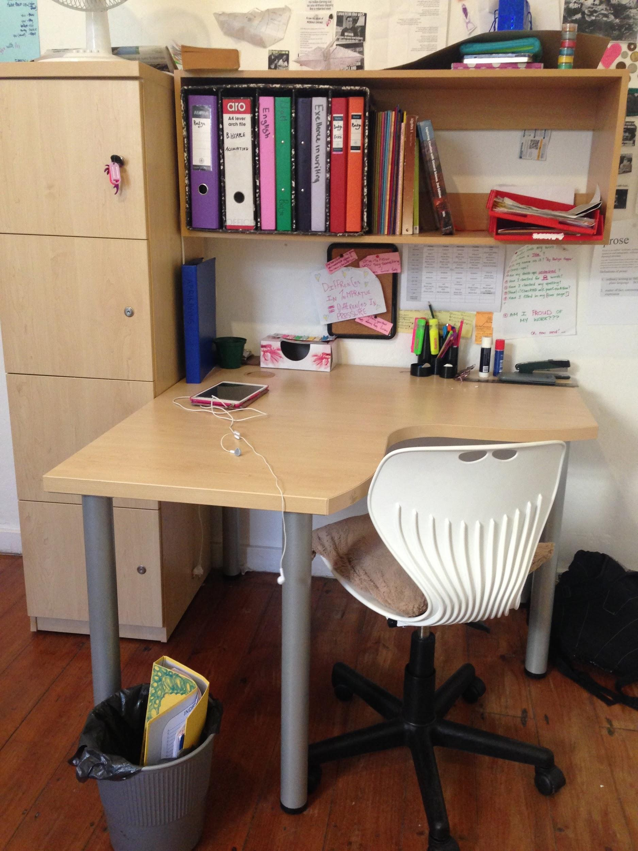

Kodesh Curriculum
Chumash
The Torah. Every letter of the five books of Moses is exact, and has layers of meaning. Lashon HaTorah, or Biblical Hebrew, the key skill for deciphering the most popular book ever printed, and we focus on the language tools needed to open it. We also teach how to pick up nuance in text, and anticipate the commentaries comments and questions.
Mishna and Gemara
The foundation of traditional Judaism. The Talmud includes Halacha (law), Jewish ethics, philosophy, customs, history, lore and many other topics. Its incisive logical structures are renowned for honing critical thinking, legal reasoning and analysis, precedent, and case studies. Also know as “the Oral Law” which was passed down from Sinai in addition to the Torah, “the Written Law”. The Gemara’s Socratic method makes its content come alive, and invites the learner to join the discussion and take a side. When we teach Gemara, we are teaching how to think in a disciplined way, how to apply Jewish Law to life, and how to make traditions and laws come alive.
Halacha
Jewish Law. We focus on the practical applications of Jewish law and lifestyle, and the moral and ethical values that remain timeless.
Parsha
The weekly Torah portion. Every week has a different vibe and energy based on the Torah portion of the week. Teachers teach their students to “live with the times” by gleaning timely and relevant messages from the Parsha of the week.
Hashkafa
Jewish philosophy and perspective. No question is frowned upon, and this subject allows frank and honest skepticism in the desire to gain knowledge and depth. We tackle the issues challenging the teenage mind, like the separation between genders, questions in belief and faith, relevance of Judaism in the modern world, in a healthy and open dialogue.
Jewish History
Jewish History is unparalleled in the history of nations. In a lighter weekly class we traverse the story of our survival and triumphs as a people, and our gifts to the world around us along the way.
Shabbat/Moadim
The calendar plays an essential role in Jewish literacy and lifestyle. This course geared to the practical celebration, teaches the laws of the Shabbat and Holidays, the laws, customs, and meanings of the days and its rituals.
Tefillah
Prayer. In addition to daily prayers, Shacharit and Mincha, we explain the meanings of the words and structure of the prayer book to allow for meaningful moments of meditation and davening.
Navi
Books of the Prophets. In addition to general Jewish History, we learn Navi, the Biblical accounts of our earliest periods, and discover the meaning and relevance of the stories to us.

General Studies Curriculum
Junior High
CTTH follows, but is not limited to, the Caps Curriculum.
Subjects offered in Junior High
- English Writing
- English Grammar and Literature
- Ivrit
- Afrikaans
- Maths
- Sciences
- History
- Geography
- Economic Management Science (EMS)
- Technology
- Accountancy
- Drama

Senior High
The Senior Division uses the University of Nebraska High School (UNHS) online platform. UNHS is consistently rated as one of the best online high school programs in the world.
The online platform delivers the subject content to be covered, supported by textbooks and CTTH teachers who teacher, facilitate and mentor as described earlier - this affords our students 24/7/365 access that is streamlined, efficient and professional, UNHS has 85 years of experience in distance education, and online education since 2001, having won numerous international excellence awards.
All courses meet the accreditation standards of the highly acclaimed and experienced accreditation body - AdvanceED, which guarantees that the teachers who set and mark the coursework, via the online portal, are highly qualified and skilled in their specialized subject area. Additionally, these courses meet many other stringent overseeing bodies' requirements, for example, NCAA (National Collegiate Athletic Association) and College Board (SAT administrators).
Our students are able to enter in at their ability level, and if necessary, accelerate if they are so able, including being afforded the opportunity to take AP (Advanced Placement) courses and dual enrolment for certain College Level courses, such as Sociology and Psychology, amongst others.
Subjects offered in Senior High
Please see the UNHS section below beginning on page 14 for the list of UNHS courses offered, graduation requirements, college prep, general diploma sequence, and a sample of an official SA Matric Certificate equivalent.

Matric
CTTH students graduate with a South African Bachelor’s Matric. Universities SA (Matriculation Board) requirements are:
USA High School Diploma from an accredited US High School
PLUS
SAT Reasoning Test with minimum scores in maths and reading
OR
Letter of admission from an appropriately accredited U.S. University

The above documents are sent to Universities SA (Matriculation Board), along with a letter of acceptance from a SA University, thereafter a Foreign Conditional Exemption Certificate is granted. (Please see an example of this certificate included here)
All students with International school leaving qualifications are required to apply for an exemption if they wish to study towards an undergraduate three-year Bachelor Degree.
A U.S. High School Diploma only is recognised by SAQA of a Matric without Bachelors (previously known as “without exemption”) and students can apply to technical universities or colleges that offer 3 year National Diplomas and that offer a 4th year BTech.

All Matrics also write the National Benchmark Test (NBT), either:
AQL (Academic and Quantitative Literacy)
OR
AQL and MAT (Maths)

Extra Curricular Activities
We are grateful to Herzlia High School for a partnership that grants our students full access to all of Herzlia’s extra mural activities to our students. CTTH will arrange the scheduling and lifting to practices, games, and tournaments.
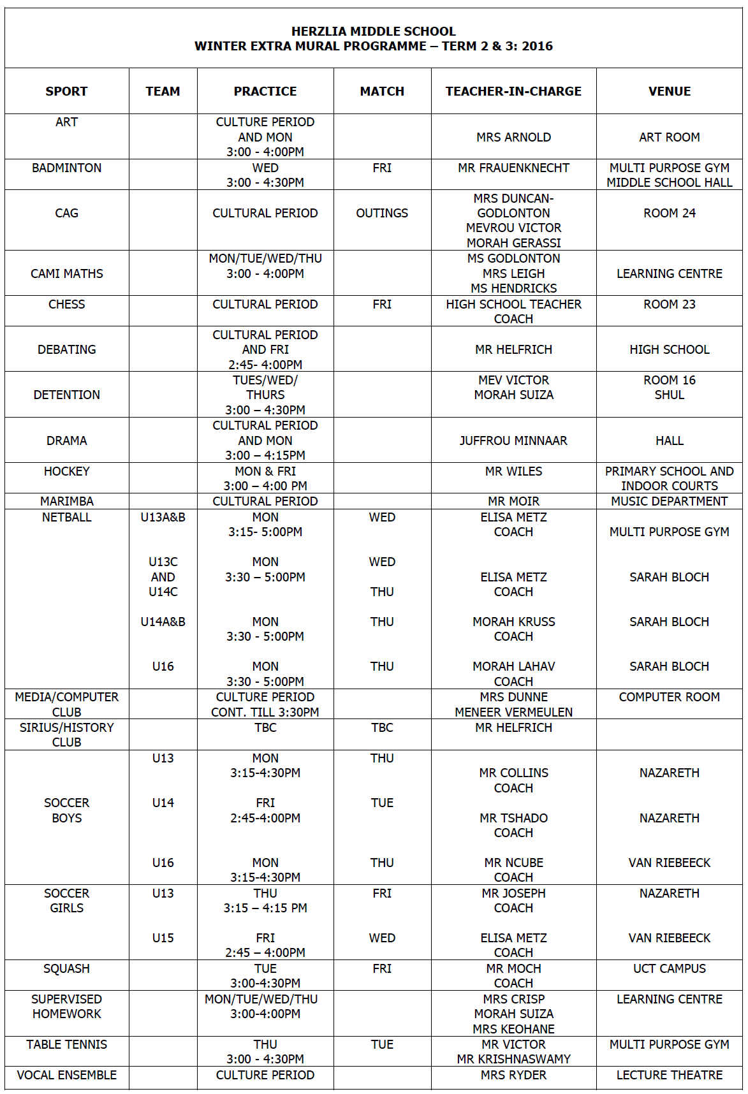

President’s Award
CTTH strongly encourages our students to participate in the President’s Award which is a proud member of the Duke of Edinburgh’s International Award Association, as part of a family of over 140 countries that operate the Award around the world.
The awards mission is to empower young people between the ages of 14 and 25, by providing a balanced, non-competitive framework for self-development that will increase their self-esteem and enhance their capacity to achieve in whatever context they find themselves: enabling them to become responsible active citizens within their communities.
The Award Programme has proven to develop a culture of self-development for young people empowering them to develop a culture of exploring their talents and potential.
Participants are expected to fulfill a certain amount of hours in five areas:
The areas are listed below with some of the examples of what our students have achieved thus far.
- Skill Development (welding, photography, skippers license)
- Physical Recreation (team sports, boxing, sailing with Jewish maritime League)
- Community Service (Friendship Circle, children’s service, homework support)
- The Adventurous Journey (A four-day hike of the Perlemoen trail, carrying their own bedding, tents and food)
- Residential Project (setting up B’nei Akiva camp, soccer tournament away from home)

The involvement of young people in these activities, changes their perception about themselves and their world. It teaches them about vital issues such as health, political and social life, as well as the environment.
Completion of the programme also equips the individual for further training and fulfilling work.
Both tertiary institutions and the place of work, increasingly see value in the Award Programme. As the youth integrate the values of the programme into their lives, they become empowered, believing that they can turn their dreams into realities. Empowered youth can make informed choices and are less likely to compromise their future.

University of Nebraska High School

See rankings of Online High Schools published by bestcollegereviews.org (number 3), the bestschools.org (number 10), geteducated.com (number 4) for examples.

